Coursework Report: Automated Cryptocurrency Tracking System
- Introduction
For this data management project, I implemented an automated system that recorded and displayed the prices of the ten leading cryptocurrencies (including BTC, ETH, and SOL) over time. The objective here was to assemble meaningful software that integrated all the various technologies that have been studied in this class: Unix Shell scripting for automation, MySQL databases for storing data persistently in databases, and Git repositories for version control.
This system operates based on a predetermined schedule that involves fetching live data from the CoinGecko API, storing data in the local database, calculating the 5-period Moving Average in relation to data trends, and generating pictures in the PNG file format.
- Unix Shell Script for Data Extraction (tracker.sh)
My project revolves around the tracker.sh script. This script essentially functions like the "controller" that bridges the API and my database.
Data Fetching & Parsing
I chose the CoinGecko API because of the clean JSON response. Rather than sending 10 requests in succession (which would take time and could possibly result in being banned), I put together the script that allowed me to get information for all 10 coins in one curl request.
For data processing, I utilized the jq tool. Initially, I had thoughts of using the cut or awk command in order to process the data. However, considering the structure of the JSON data received from the API in a nested manner, the use of jq would be more effective in fetching me the required information regarding the USD and usd_24h_change values.
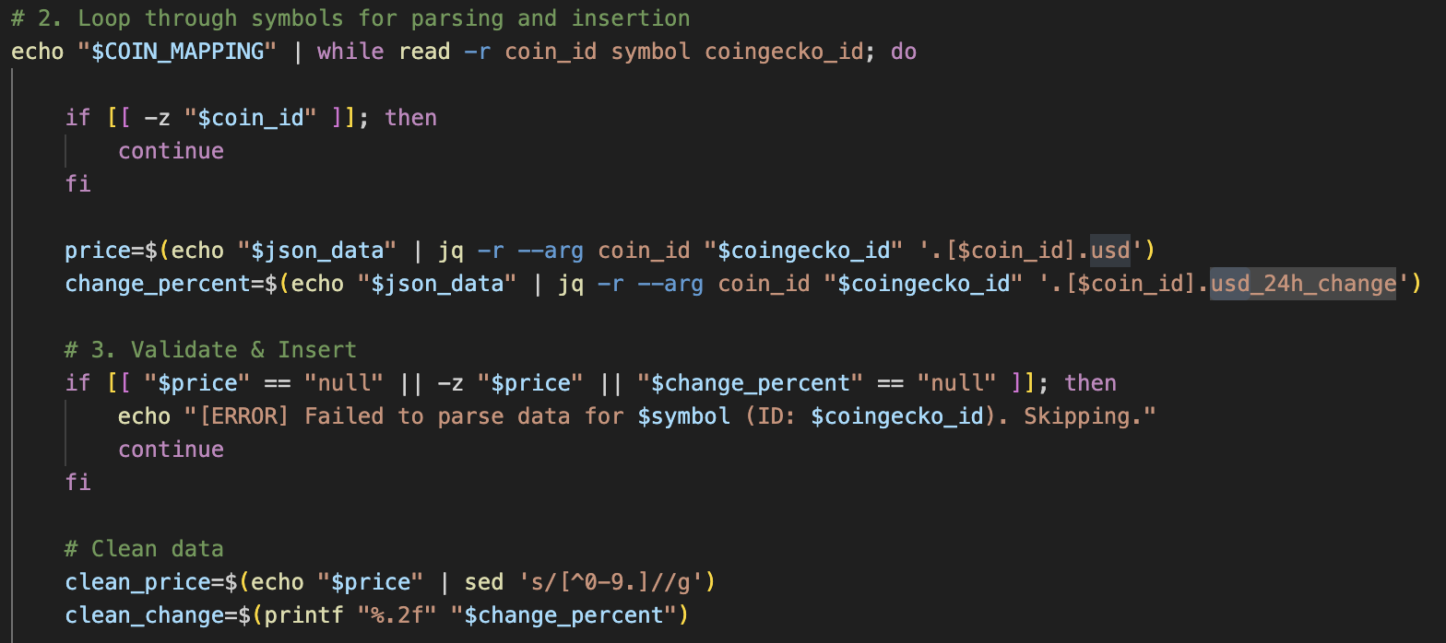
The is the snippet demonstrating how I address the JSON parsing. I dynamically extract the price for each coin in the loop by passing coin_id to jq. I also added a cleaning step by using sed to strip any non-numeric characters.
The Logic Complexity: Moving Average
The most difficult piece of this script was the calculation of the 5-period Simple Moving Average. I could not simply use the current market price; I had to consider the past prices.
- Unpacking History:
The function that I developed searches MySQL with a query that selects the latest 4 recorded prices based upon the symbol being processed.
- Calculation:
Since Bash does not perform floating math natively, I piped the math calculations through the bc (Basic Calculator) command in order to make sure decimal precision values were correct. The result of this calculation would be piped.
- Dealing with New Data:
I implemented the logic to tackle the "cold start" issue. The script assigns the value NULL to the MA if there are more data points less than 2 in the DB.
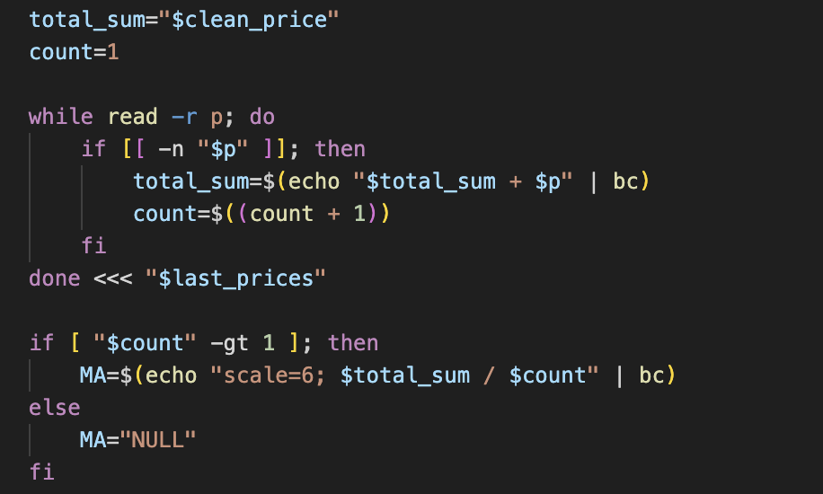
Since Bash handles integer arithmetic, standard division would have resulted in inaccurate truncated values. As shown in the code above, I piped the calculation into bc with scale=6. This ensures the Moving Average retains 6 decimal places of precision, matching the database schema.
Database Interaction
I developed another function titled run_sql, responsible for running all commands in the database. However, upon testing the function, I observed that MySQL warnings such as "Using a password on the command line interface." in MySQL were messing up the assignments in my variables. I altered this by including 2>/dev/null in the function to eliminate those warnings and have only data retrieved back in my script.
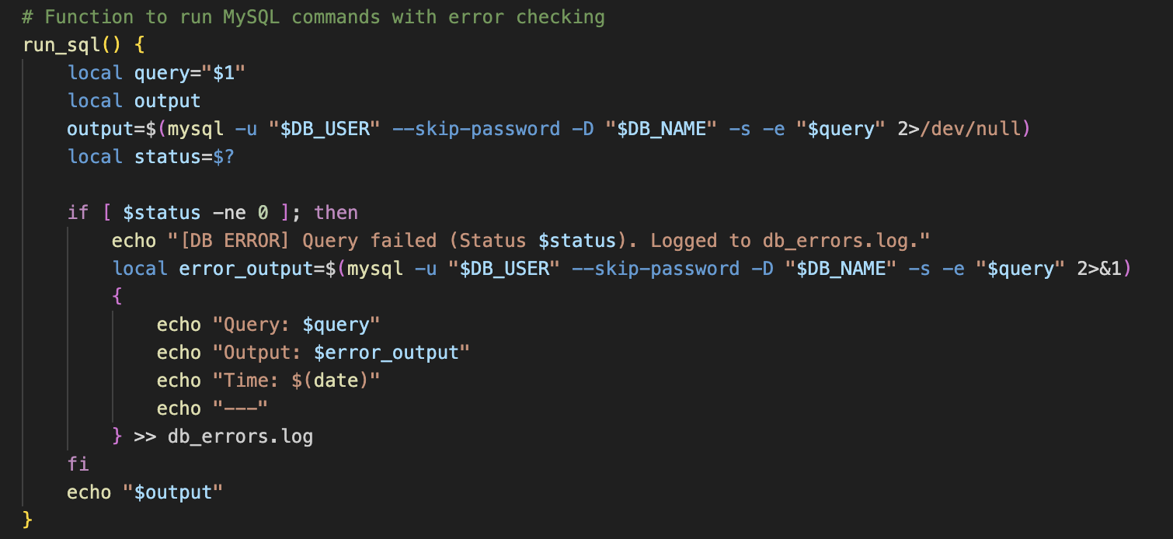
This function wraps every SQL call. The critical component here is 2>/dev/null, which separates the actual data output from MySQL’s security warnings. Without this, the warnings would be captured into variables like $last_prices, causing the arithmetic logic to crash. It also logs any actual query failures to db_errors.log for debugging.
- MySQL Storage Database
I chose MySQL databases because storing data in flat files such as text/CSV files makes querying (especially when computing averages) inefficient.
Database Design
I designed three table schema focused on time-series cryptocurrency data. The Entity-Relationship Diagram (ERD) below illustrates the core entity and its relationships(keys):
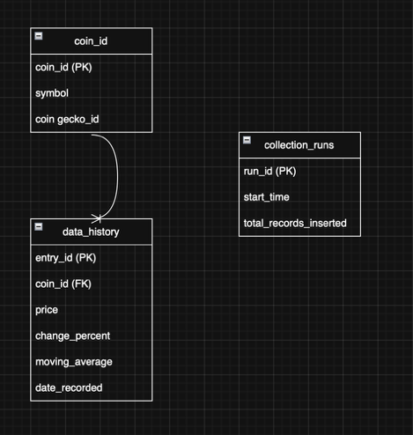
Coins: Stores static metadata like the symbol (eg. BTC) and the coingecko_id (eg. Bitcoin). The coin_id is the Primary Key.
data_history: Stores all time-series data, including price, change_percent, and moving _average. It links back to the coins table via a Foreign Key (coin_id), replacing the need to store the symbol repeatedly for every record.
collection_runs: Logs the start_time and total_records_inserted for each successful tracker.sh execution.
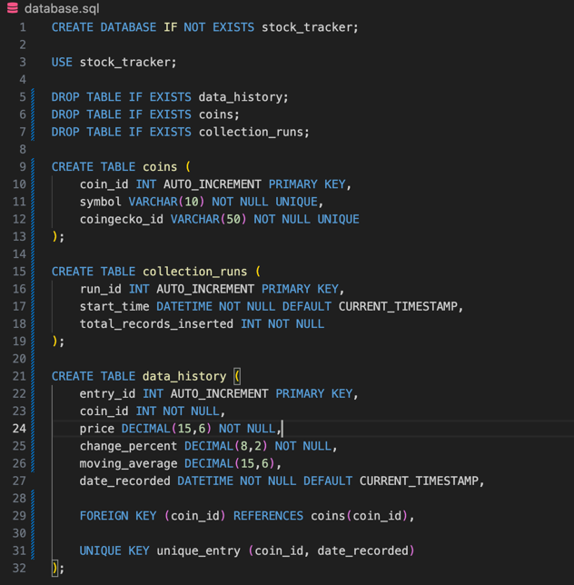
The SQL structure shows the use of DECIMAL(15, 6) for prise precision. I also added a UNIQUE KEY constraint on coin_id and date_recorded as a fail-safe; if the cron job were to accidentally trigger the script twice in the same second, the database would reject the duplicate entry rather than corrupting the dataset.
- Visualizing the Data (plotter.sh)
To be able to use the data gathered in this project, I developed the plotter.sh script. The choice of Ginuplot in this project was based on the fact that this tool can be scripted entirely from the command line interface. This renders it ideal for this project.
Data Formatting
Gnuplot has strict requirements concerning data format. For data extraction from the MySQL database into this temporary file (temp_plot_data.dat), I wrote this query: However, the major issue encountered in this project is that MySQL data often has hidden (\r) carriage return symbols that cause Gnuplot data rendering problems. The issue has been resolved using tr -d '\r'.
The Graphs
The script produces the PNG image file based on the symbol passed (e.g., ./plotter.sh BTC). The lines in this graph are:
- The Price: Shown with points and lines.
- The Moving Average: A smoothed line plotted atop the price charts in order to reveal the trend.
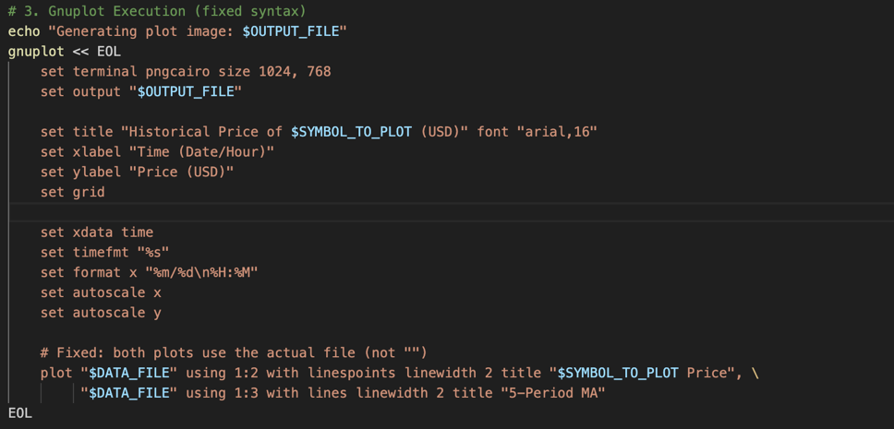
This ‘Here Document’ block automates the graph generation. I configured the X-axis to interpret raw Unix timestamps (%s) from the database but display them in a human-readable Month/Day format. The plot command draws two distinct series from the same data source: the raw price with points for detail, and the Moving Average with a solid line to visualize the trend.
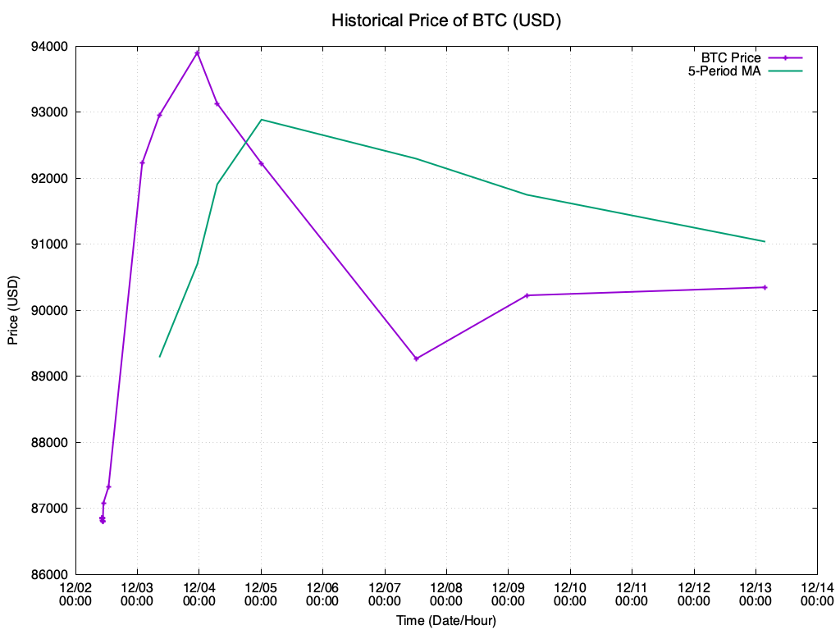
To save time, I also developed another script wrapper named ‘generate_all_plots.sh’ that automatically loops through the entire list of symbols that I have and executes the plotter script for each symbol.
- Version Control (Git)
Throughout the process of coding, I utilized Git. This was especially helpful in terms of debugging my code in the Moving Average section.
- Commit History: I made commits when I finished particular features (such as "Creating database" or "Debug for calculating moving average").
- Error Recovery: Once, I broke the database insertion loop. But since I knew I had previously committed my working code, I was able to look through code changes and correct those changes. This allowed me to return my code to the working stage.
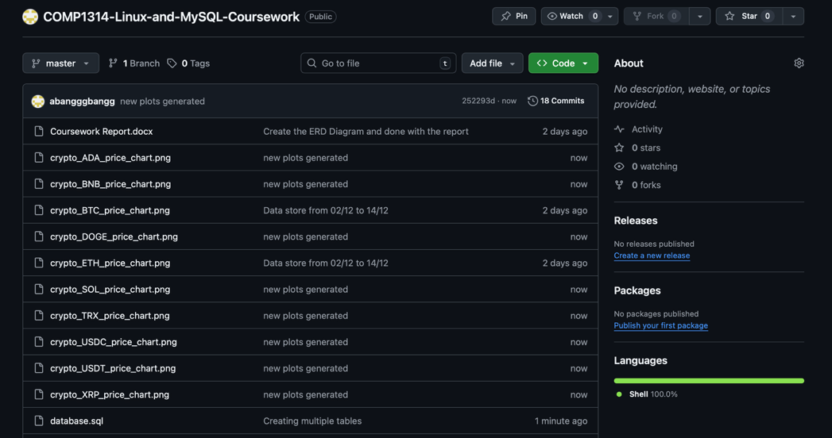
- Conclusion
This project also managed to automate tracking information related to cryptocurrencies. Even if there are challenges encountered in this project, like in MySQL's result formatting and floating point calculations in Bash, those challenges have been overcome through improvements in the code scripts. The final system is robust, handles errors (by logging them to db_errors.log), and produces clear visual reports.

